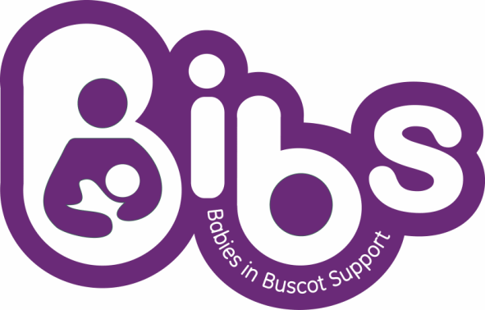
Gift Aid Declaration

Gift Aid is a government scheme allowing BIBS to reclaim tax on your donation at no extra cost to you. To allow BIBS to claim Gift Aid just complete the form and return to BIBS at the address below
I would like to treat all qualifying gifts of money made
- today, with a value of £ …………….
- in the past 4 years
- in the future
Please tick all boxes you wish to apply.
I confirm I have paid or will pay an amount of Income Tax and/or Capital Gains Tax for each tax year (6 April to 5 April) that is at least equal to the amount of tax that all the charities or Community Amateur Sports Clubs (CASCs) that I donate to will reclaim on my gifts for that tax year. I understand that other taxes such as VAT and Council Tax do not qualify. I understand the charity will reclaim 28p of tax on every £1 that I gave up to 5 April 2008 and will reclaim 25p of tax on every £1 that I give on or after 6 April 2008.

Donor’s details
Title ……………. First name or initial(s) …………………………………………………..
Surname ………………………………………………………………………………………
Full home address …………………………………………………………………………… …………………………………………………………………Postcode ……………………

Date ………………………… Signature ………………………………….…………………

Please return to:
BIBS, Buscot Ward, Royal Berkshire Hospital, London Road, Reading RG1 5AN

Please notify the BIBS if you:

Want to cancel this declaration

Change your name or home address

No longer pay sufficient tax on your income and/or capital gains.

If you pay Income Tax at the higher or additional rate and want to receive the additional tax relief due to you, you must include all your Gift Aid donations on your Self Assessment tax return or ask HM Revenue and Customs to adjust your tax code.

